Name: Shivanagouda Patil
Lab: Lab 5 — Static Code Analysis
Assigned repository: L5_34_online_exam
Main submission repository: SE_LAB_PES2UG24CS471_SEC_H

Before
Pylint report –
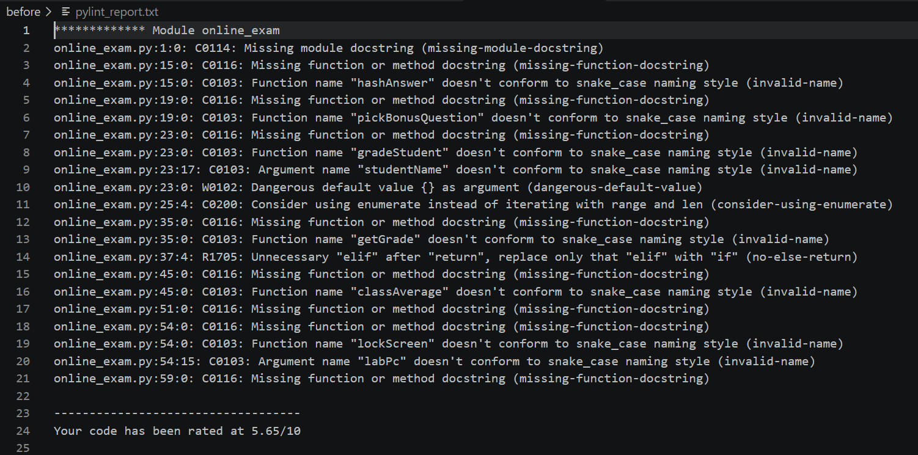
Bandit report
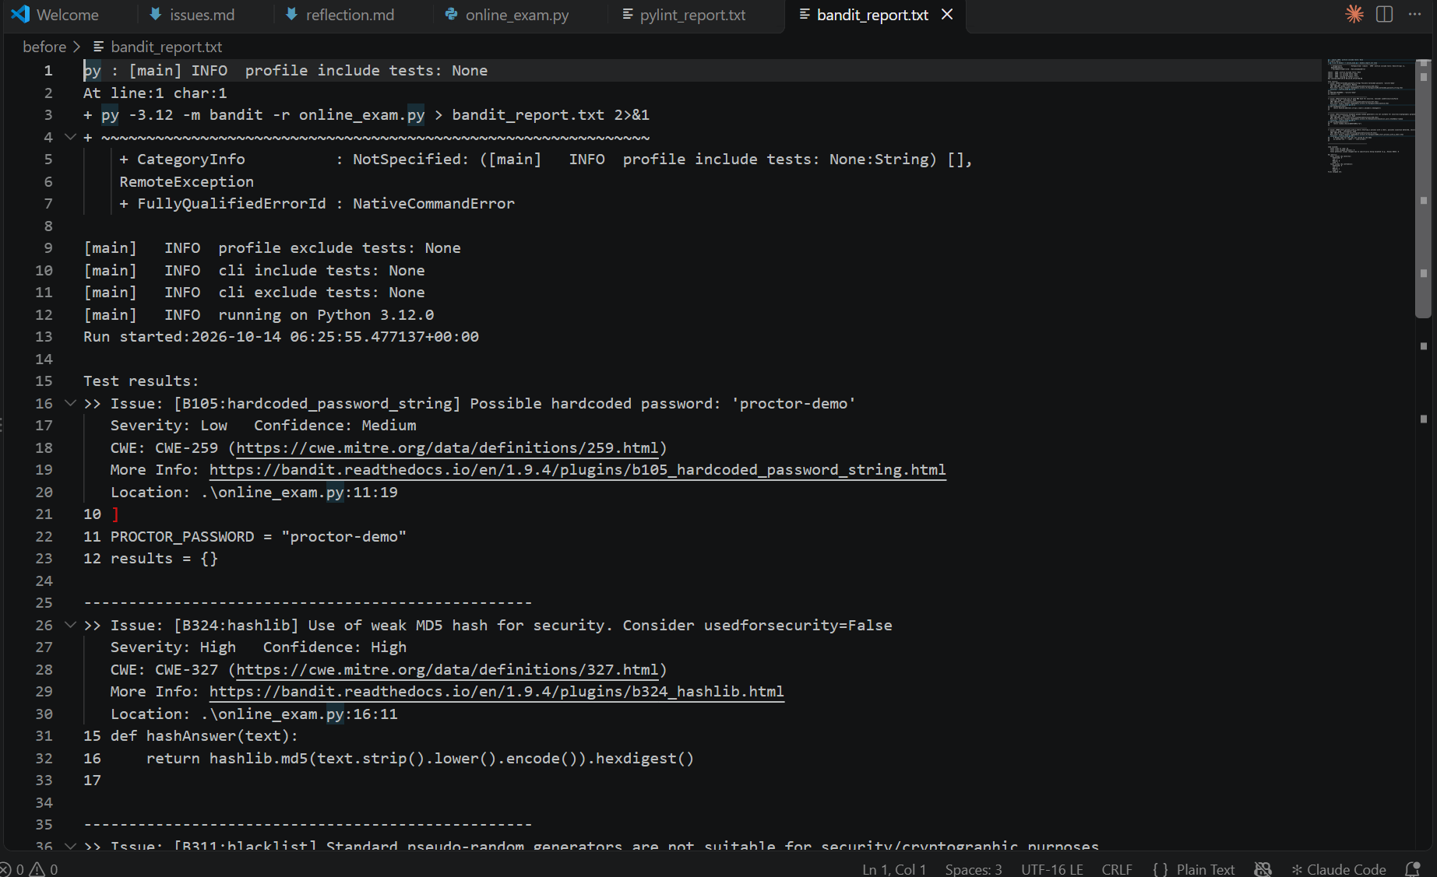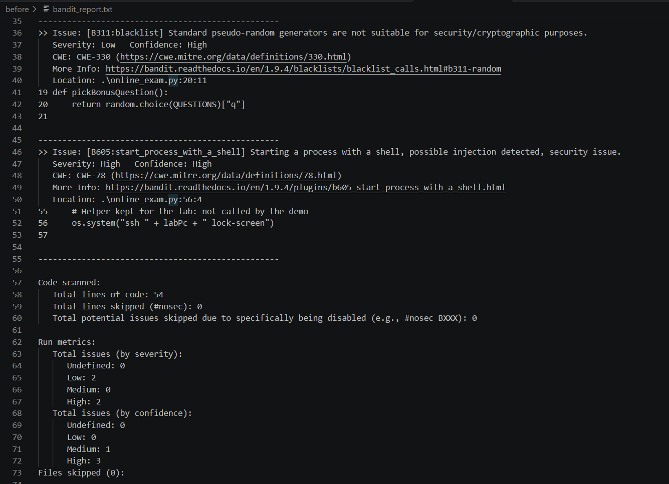
Flake8 report
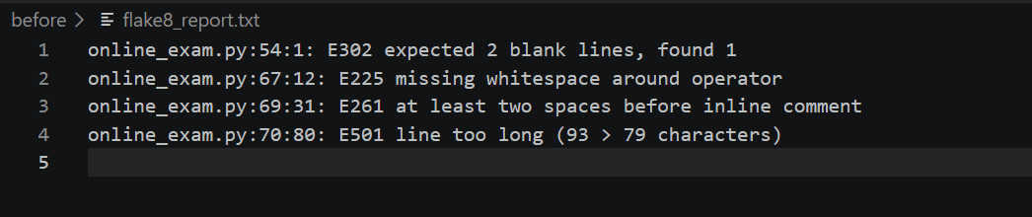
After
Pylint report
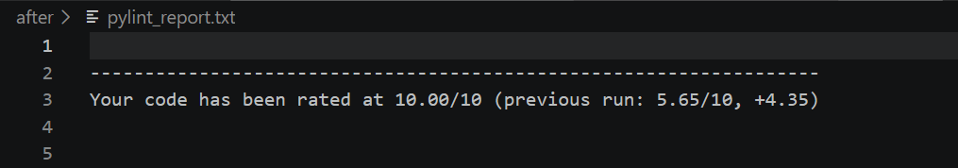
Fleak8 report - empty
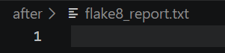
Bandit report
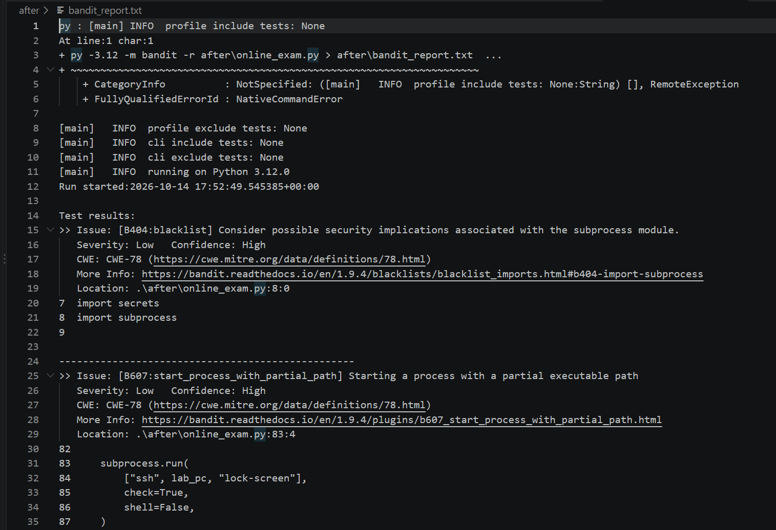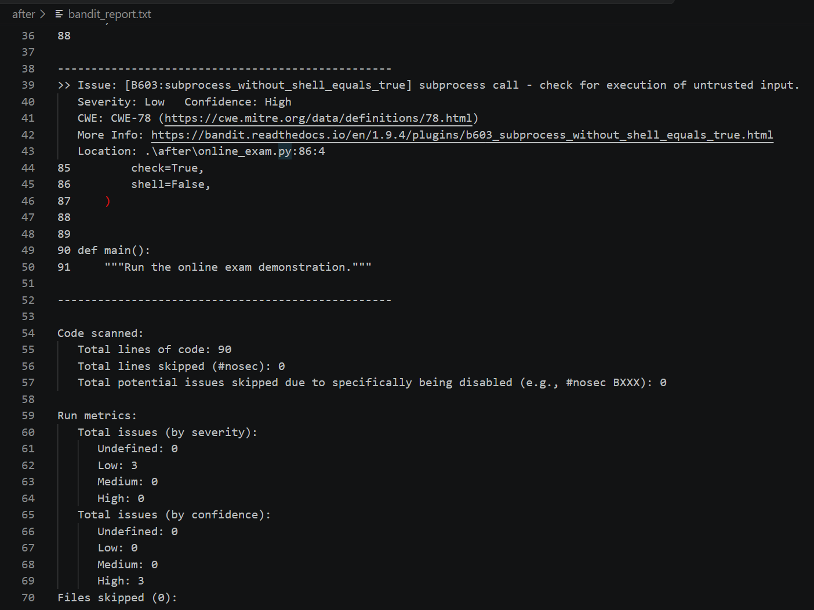

Lab 5: Static Code Analysis — Issue Documentation
Objective
To identify, document, and fix issues in the online_exam.py program using Pylint, Bandit, and Flake8.
Issues Identified and Fixed
Issue | Type | Original Line(s) | Description | Fix Approach
Weak MD5 hashing | Security | 16 | MD5 is not suitable for security-sensitive hashing. | Replaced MD5 with SHA-256 for normalized answer comparison.
Hardcoded proctor password | Security | 11 | The password was stored directly in the source code. | Read the password from an environment variable using os.getenv().
Unsafe shell command execution | Security | 56 | os.system() used string concatenation to construct a shell command. | Replaced it with subprocess.run(), shell=False, and computer-name validation.
Mutable default argument | Bug / Code quality | 23 | penalties={} could share a dictionary between calls. | Changed the default to None and initialized a dictionary inside the function.
Non-standard function names | Code quality | 15, 19, 23, 35, 45, 54 | Function names did not follow the recommended snake_case convention. | Renamed functions and updated their calls.
Missing docstrings | Code quality | Multiple | Functions and the module lacked documentation. | Added module and function docstrings.
Loop improvement | Code quality | 25 | The loop used range(len(QUESTIONS)). | Used enumerate() to iterate through questions.
Formatting violations | Style | 54, 67, 69, 70 | Flake8 reported blank-line, whitespace, inline-comment, and line-length violations. | Corrected spacing and formatting.
Verification
After the fixes, the static analysis tools were run again.
- Pylint score improved from 5.65/10 to 10.00/10.
- Bandit no longer reported the original two high-severity and two low-severity findings. The updated report contained three low-severity subprocess-related findings.
- Flake8 produced an empty report, indicating that no style violations were reported.
Conclusion
Static analysis helped identify code-quality issues, security concerns, and style violations. The fixes improved readability and addressed the major findings from the original reports. The updated reports were used to verify the results.

Lab 5: Static Code Analysis — Reflection
1. What is static code analysis, and why is it useful?
Static code analysis examines source code without executing the program. It helps identify potential bugs, security vulnerabilities, and coding-style violations early in development. This improves code quality, readability, and maintainability.
2. What is the difference between Pylint, Bandit, and Flake8?
Pylint focuses on code quality, programming practices, and potential logical errors. Bandit identifies common security vulnerabilities and insecure coding patterns. Flake8 checks Python style conventions and common programming errors.
3. What issues did you identify and fix during this lab?
I addressed the use of MD5 hashing, a hardcoded proctor password, shell command execution using os.system(), and a mutable default argument. I also improved function naming, documentation, and code formatting.
4. How did static analysis help improve your program?
Static analysis provided actionable feedback about code quality, security, and formatting. The Pylint score improved from 5.65/10 to 10.00/10, the original high-severity Bandit findings were no longer reported, and Flake8 reported no remaining style violations. Bandit still reported three low-severity findings, which highlighted the importance of reviewing and interpreting warnings rather than assuming every issue has been eliminated.
Conclusion
This lab demonstrated how static analysis tools can help developers identify and correct problems before deployment. Using multiple tools provided complementary checks for code quality, security, and consistency.

